**Topic:** Does Root Beer Have Caffeinein 2022 – Vigoursoul

**Focus keyword:** Does Root Beer Have Caffeine

**Meta Title:** Does Root Beer Have Caffeine in 2022 – Vigoursoul

**Meta Description:** If you're trying to restrict or avoid caffeine, you might be wondering if root beer includes it. This article discusses whether root beer contains caffeine and how to test for it.

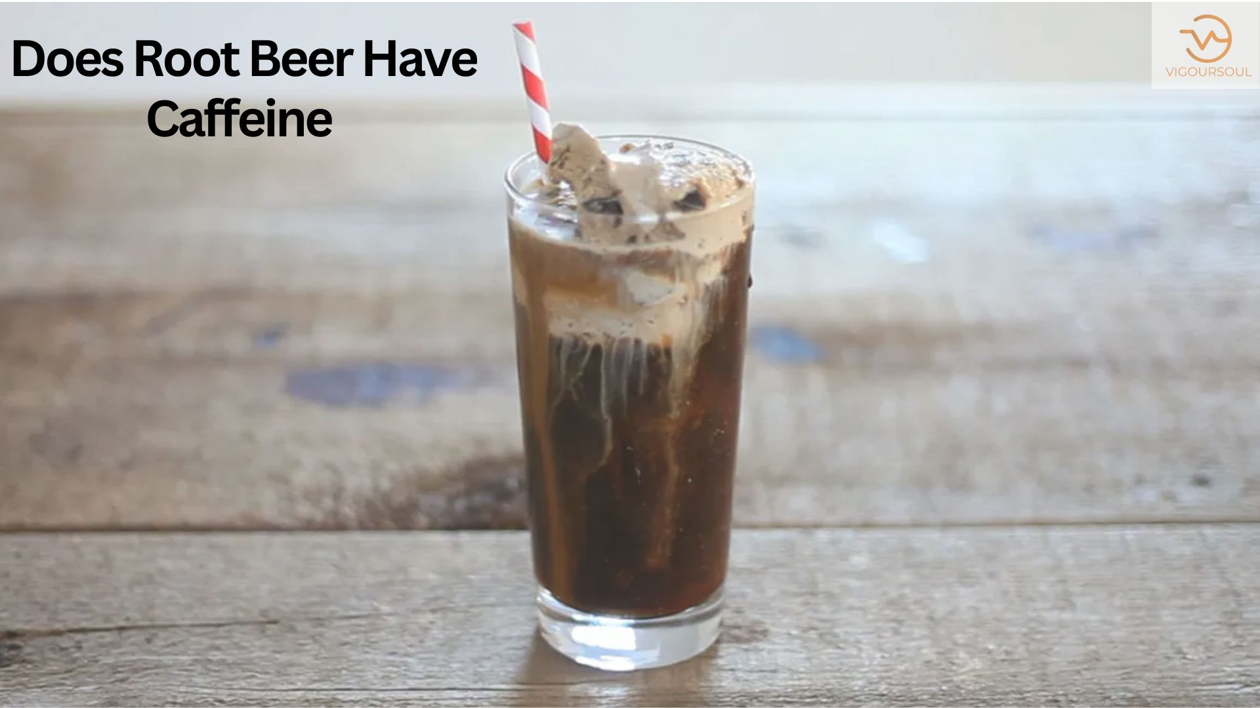

Caffeine is a naturally occurring substance that stimulates the central nervous system, increasing alertness and combating weariness. It may be found in many plants' leaves, seeds, and fruits, but it is most prominent in cocoa beans, tea leaves, and coffee beans .It's also often found in a variety of items, including soft drinks, energy drinks, and over-the-counter pharmaceuticals. Caffeine is becoming one of the most regularly ingested compounds all over the world (4Trusted Source).

**Table of content:**

## Does Root Beer Have Caffeine?

Root beer is a thick, creamy soft drink that is popular throughout North America.

While most people are aware that other types of cola frequently include caffeine, many are unaware of the caffeine concentration of root beer.

This is especially troublesome if you're attempting to reduce or eliminate coffee from your diet.

### Does Berks Root Beer Have Caffeine?

Although most root beer is caffeine-free, certain kinds may contain a trace. The caffeine level of the brand Barq's is particularly significant. Each 12-ounce (355-ml) can of regular contains around 22 milligrammes. The diet version, on the other hand, has none (1)

### Does Mug Root Beer Have Caffeine?

Root beer also contains a lot of caffeine, which can disrupt your sleep cycles and cause insomnia!

### Does ibc Root Beer Have Caffeine?

IBC Root Beer has no caffeine. This is a prominent Root Beer brand that was founded in 1919 by the Independent Breweries Company in St. Louis.

### Does Culver's Root Beer Have Caffeine?

Culver's has been in business since 1984, and its root beer is caffeine-free as well.

Most root beer is caffeine-free**:**

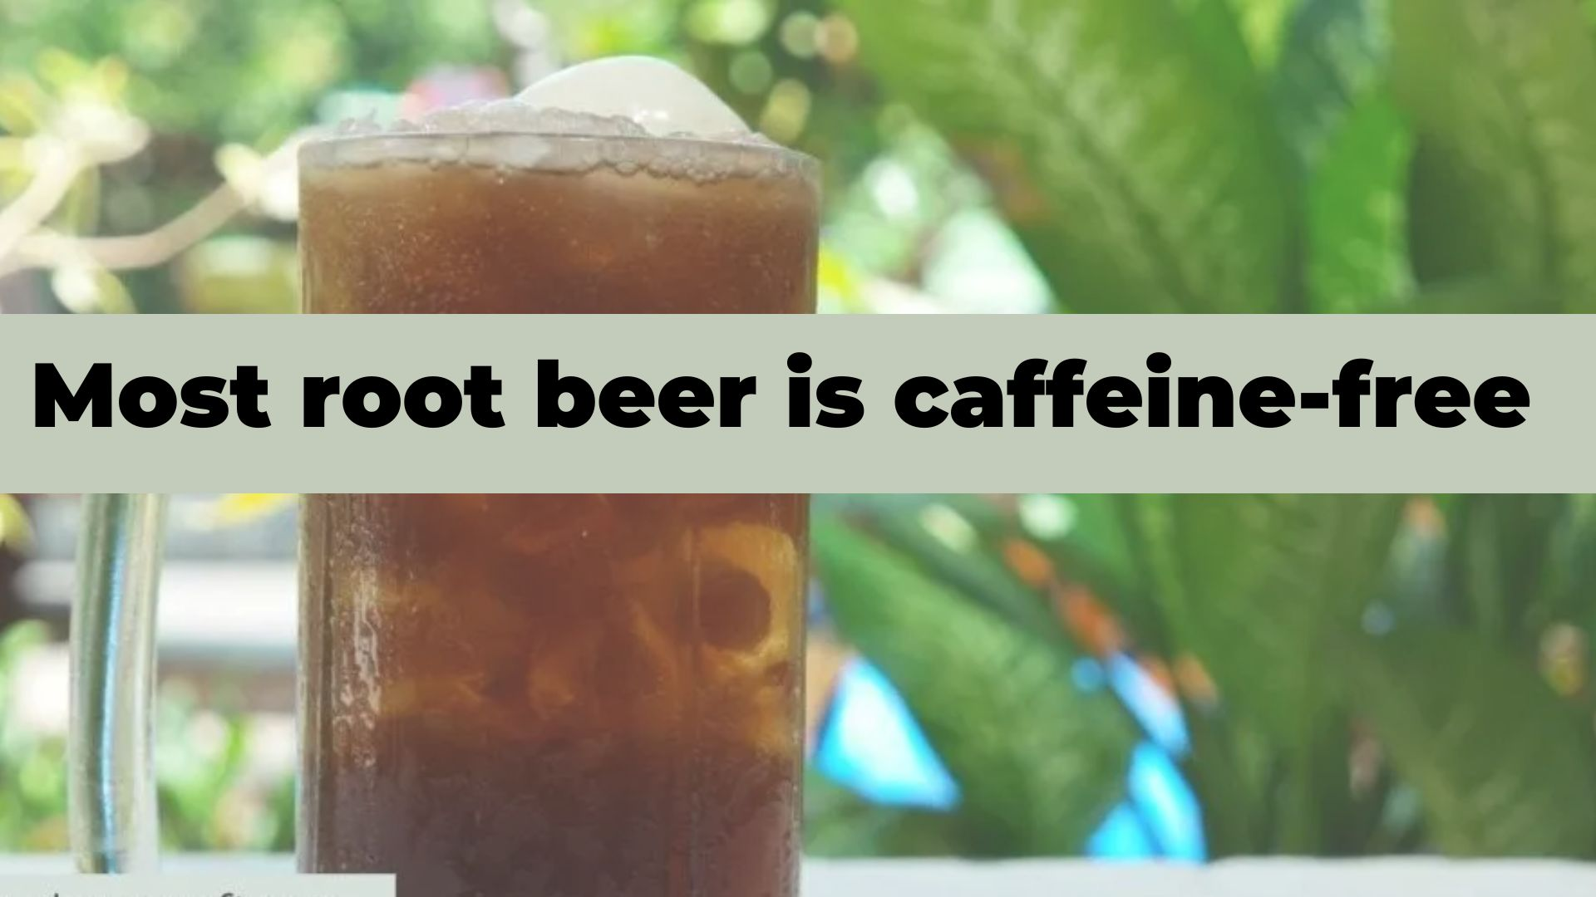

Most root beer brands offered in North America are caffeine-free.

Although the contents vary depending on the brand and product, the majority of varieties of this popular beverage comprise carbonated water, sugar, food coloring, and artificial flavors.

However, only a few brands contain caffeine.

The following are a few popular caffeine-free root beer brands:

* A&W Root Beer
* Diet A&W Root Beer
* Mug Root Beer
* Diet Mug Root Beer
* Dad’s Root Beer
* Diet Dad’s Root Beer
* Barq’s Diet Root Beer

### Some Types May Contain Caffeine:

Although most root beer is caffeine-free, certain kinds may contain a trace.

The caffeine level of the brand Barq's is particularly significant.

* Each 12-ounce (355-ml) can of regular contains around 22 milligrammes. The diet version, on the other hand, has none (1).
* A standard 8-ounce (240-ml) cup of coffee has around 96 mg of caffeine, which is almost four times the amount in a can of Barq's (2Trusted Source).
* Other caffeinated beverages, such as green or black tea, have more caffeine, often comprising 28-48 mg per cup (240 ml)

## How to Check for Caffeine:

Caffeine-containing foods, such as coffee, tea, and chocolate, may not list it explicitly on the label (5Trusted Source).

* Caffeine-containing goods, such as certain variants of root beer, must, nevertheless, declare it on the ingredient label.
* Remember that the Food and Drug Administration (FDA) does not compel manufacturers to disclose the precise quantity of caffeine added to food goods (6Trusted Source).
* As a result, the easiest approach to find out how much a certain product contains is to visit the product's website or contact the manufacturer directly.

### Is Root Beer Healthy?

* In general, no soda is considered "healthy."
* However, certain sodas are regarded healthier than others.
* Various cola brands, including Coca-Cola, contain phosphoric acid, which is known to erode away at the enamel of the teeth, causing cavities.

### Is Sprite Caffeine-Free?

Sprite, a lemon-lime soda produced by Coca-Cola, is popular for its refreshing, citrusy flavour.

Still, certain drinks contain a lot of caffeine, and you may be wondering if Sprite is one of them, especially if you're attempting to restrict your caffeine intake.

This article discusses whether Sprite includes caffeine and who should avoid it, as well as other sodas.

**FAQS**

**Is There Caffeine in A&W Root Beer?**

A&W Root Beer contains no caffeine and is created with aged vanilla for a sweet and smooth flavour that has become the industry standard in root beer soft beverages. A&W tastes finest in an ice-cold mug or with vanilla ice cream for a delectable root beer float.

**Why Does Root Beer have no Caffeine?**

We examined many soda brands and discovered that Mountain Dew Zero Sugar contains the highest caffeine. It has 5.7 milligrammes (mg) of caffeine per ounce, thus a 12-ounce can contains around 68.4 mg, and a 20-ounce bottle contains approximately 114 mg.

**What is the Healthiest root Beer to Drink?**

If you want a root beer with a distinct flavor and no calories, Virgil's Zero Sugar root beer is the drink for you. This bottled root beer is sweetened with Stevia, which helps to eliminate all calories while maintaining the deep and earthy flavor of Virgil's brand.

**Why is IBC Root Beer so Good?**

There's a reason IBC Root Beer can be found everywhere. It's an easy-to-like brew. It has a taste that places it towards the top of the standard root beer spectrum. It's certainly better and more polished than an A&W or a Barq's, but it's not quite excellent enough to crack the top tier.

**Why is it called Root Beer If there is no Alcohol?**

Hires originally intended to name the product "Root Tea," but changed it to "Root Beer" to appeal to Pennsylvanian coal workers. Hires advertised root beer as a non-alcoholic alternative to alcohol.

**Conclusion:**

Root beer in cans is one of the most popular types of drink in the United States, and with good reason.

Famous Root beer, as it is traditionally produced, does not contain caffeine, although some brands do add caffeine to give it a boost.

Caffeine should be listed as an ingredient in root beer. So it's ideal if you never have a root beer soft drink with caffeine, but that doesn't change anything.

For More Blogs:[https://vigoursoul.com](https://vigoursoul.com/)

[Hotels With Smoking Rooms in 2022 | vigoursoul](https://vigoursoul.com/hotels-with-smoking-rooms-in-2022-vigoursoul/)

[Alcohol and other Drug in 2022 | vigoursoul](https://vigoursoul.com/alcohol-and-other-drugs-in-2022/)

[Tobacco Inferior for Health in 2022 – Vigoursoul](https://vigoursoul.com/tobacco-inferior-for-health-in-2022/)